Instructions for Reviewers

Step One: Confirm Whether You Will Review
An editor has sent you an email to you requesting review of a submission. Below are instructions on how to respond to and complete a reviewer’s report.
- Click on the link in the email.

- This will lead you to a webpage where you can agree to do the review. You will not be able to download the PDF until “I will review it” has been selected.
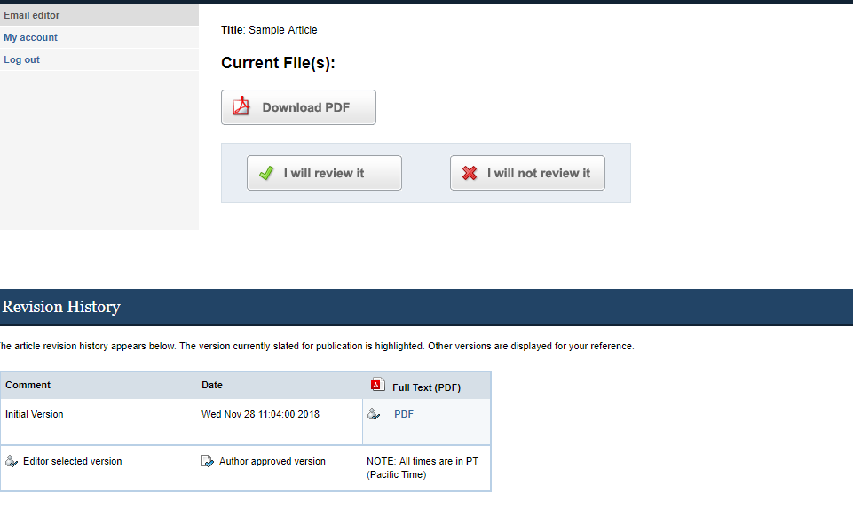
- Click on either "I will review it" or "I will not review it" to indicate whether you will return a review within the requested time frame. Please note that the email from the editor will either contain a specific due date or a number of days that the review should be completed in. If a certain number of days is specified, these days will begin counting down once you agree to the review.
Need help?
- If the link in the email does not work, or you are unable to retrieve the original email, go to https://digitalcommons.umassglobal.edu/myaccount.cgi. Once you have logged in, click on the title of the submission, and follow the prompts above.
- If it is your first time logging in, please click “Sign up” when prompted to login and please make sure to sign up for an account using the email address that received the review request. An email will be sent to you with a button to confirm your email address. Click the “Confirm Account” button, and you should be logged in afterward:
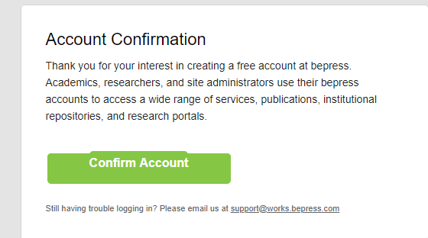

Step Two: Conduct Your Review

- Download the PDF from the webpage in Step One.

- Read and use the Review Rubric to write your review. This rubric helps create comparable bases of analysis for each submission. Please take care not to include references that may reveal your identity, as editors may choose to share your review with the authors.

- Write your letter to the editor (Optional). If you have additional comments that are for "editors-only," prepare them in a separate file from your review

Please note that you may receive reminders from the system to help you keep track of deadlines. If you will be unable to make your review deadline, please let the editors know. You can do this by using the link in the email to access the submission’s page, and then click on the sidebar link "Email editors." You can also do this by logging into your Digital Commons account, clicking on the title of the submission and then clicking the “Email editors” link.

Step Three: Submit Your Review

- Click on the link in the request email or log into your Digital Commons account and click on the title of the submission that is under review.

- Click on the link "Submit Review."

- Complete the review form. Note that you may upload your review and your cover letter in either Microsoft Word or RTF format on the form below:
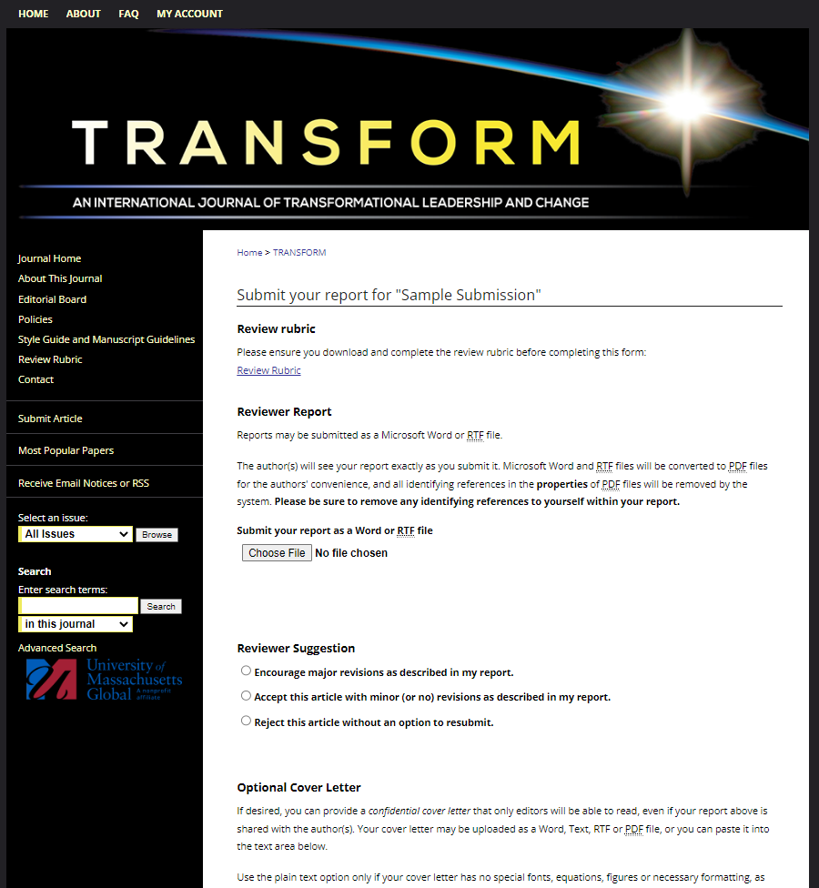
- Click “Submit” at the bottom of the form to complete your review.
- You will receive an email indicating that your review is complete, and the editors will be notified as well. Thank you for your time and assistance.

For Further Assistance
For assistance with the content of your review, or if you would like to volunteer to review, contact the editors at transform@umassglobal.edu.
For technical assistance with your account or submitting your review, please contact Digital Commons Consulting Services at 510-665-1200, ext. 2, or email dc-support@bepress.com.

